**How to Install “USB Maintenance & Management”:**

1. Run the CD which has the “USB Maintenance & Management” setup.
2. Then run the setup.
3. The setup runs in full screen:

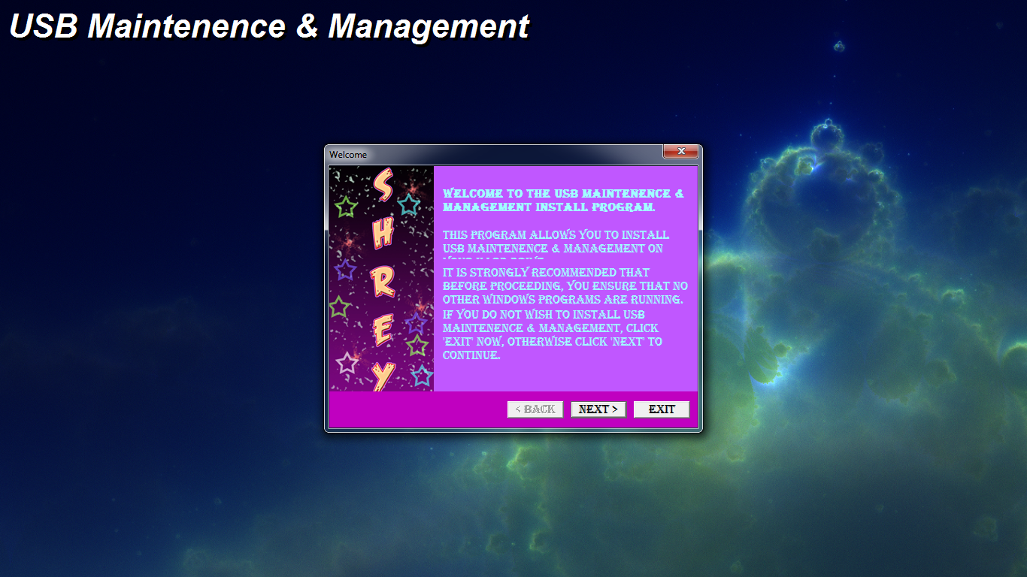

1. Click on next.

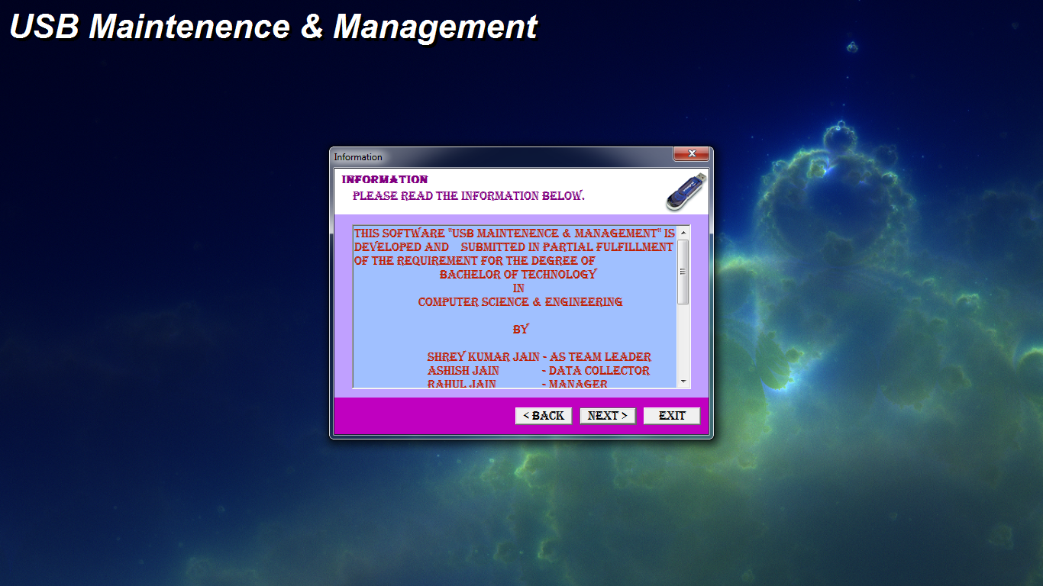

1. Click on next.

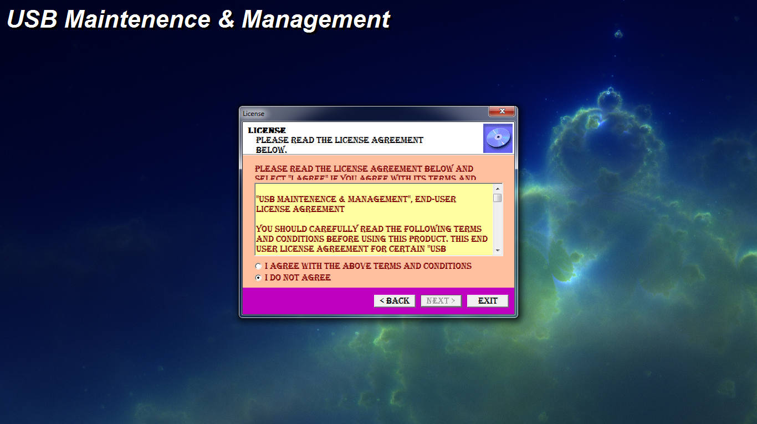

1. Select I agree Radio button after reading all Licence terms.
2. Then click next.

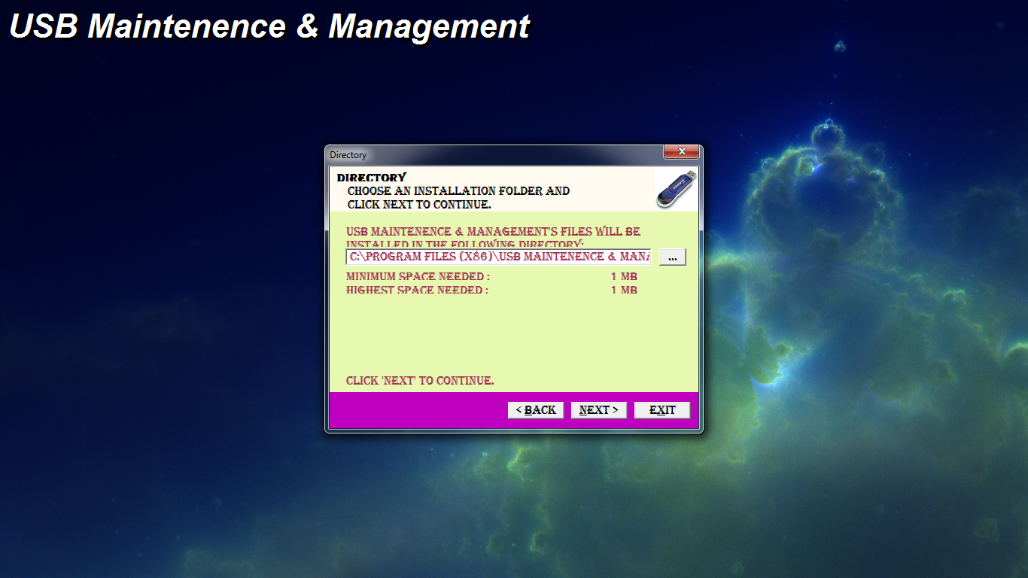

1. Click on the Start Button to Start installation process.

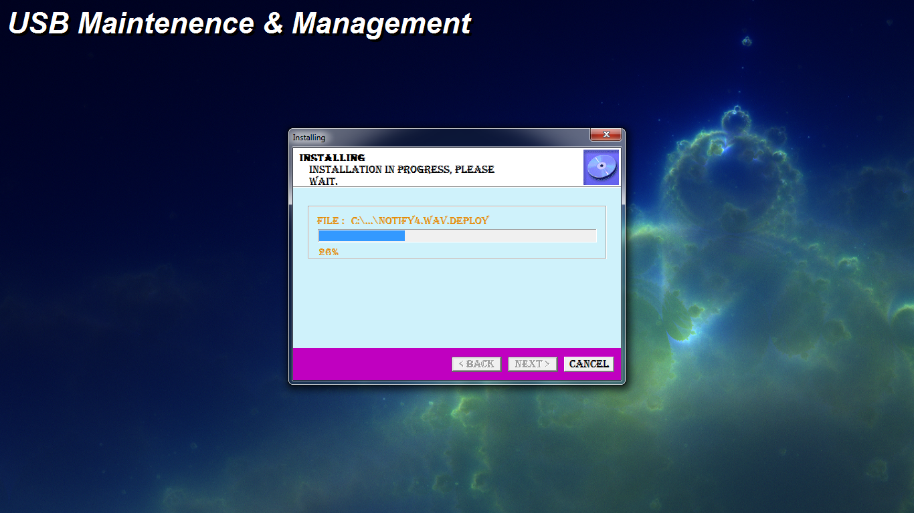

1. Finish Installation :

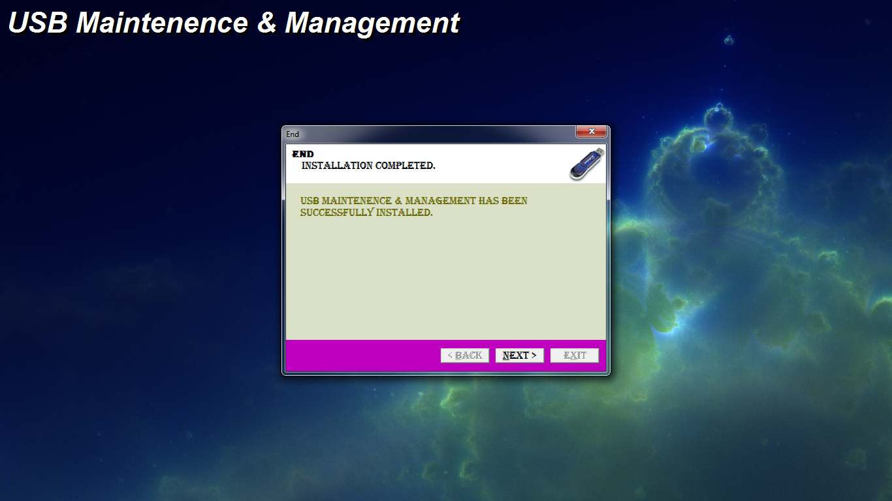

The installation file is created by the help of “Install Creator- by Click team” ver 2.0.